Joins:

Is used to combine data from two or more tables.

Inner join

Left join

Right join

Full join

Self join

Cross join

Natural join

Inner join : selects all rows from both the tables as long as the conditions is satisfied.

Select t1.c1,t1.c2,t2.c1,t2.c2

From t1

Inner join t2

On t1.c=t2.c;

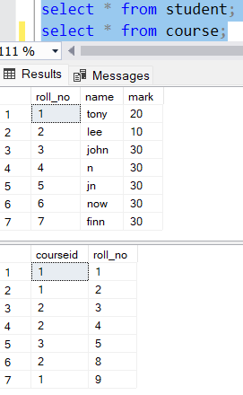

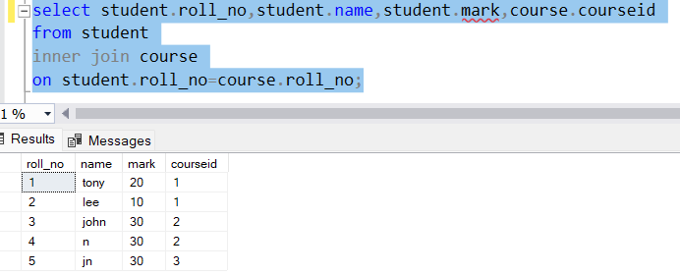

Left join:returns all the rows of the left table and matching rows from the right table,for rows which are not matching on right side itreturns null.

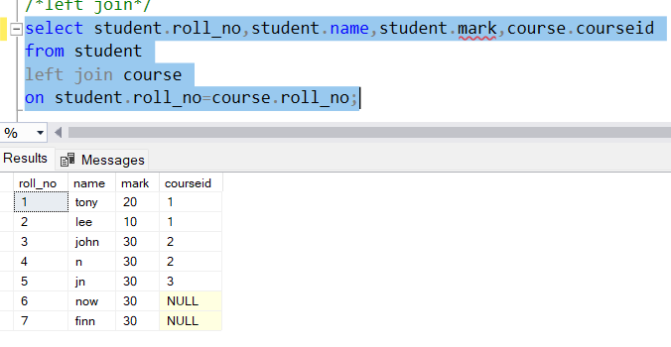

Right join: returns all the rows of the right table and matching rows from the left table,for rows which are not matching on left side It returns null.

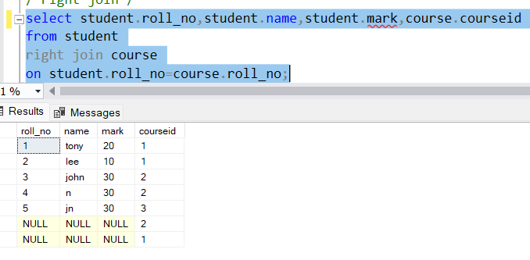

Self join:

Joins a table with itself,

Combines the rows from the same table based on specific conditions

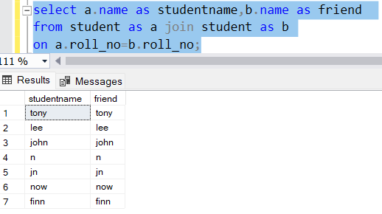

Cross join:

Generates paired combination of each row of first table with each row of the secondtable

Select t1.c1,t1.c2,t2.c1,t2.c2

From t1

Cross join t2;

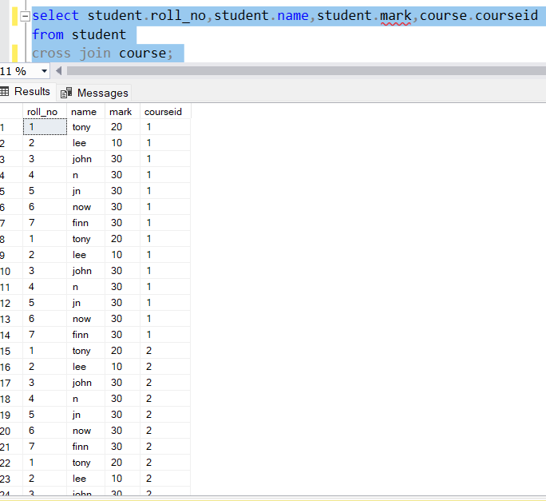

Total of 49 rows gets returned

Natural join: A natural join returns all rows by matching values in common columns having same name and data type of columns and that column should be present in both tables.

Select *

From table1

Natural join table2;

Difference between natural join and inner join is that :

Common column returned only once in natural join if we try to retrieve all the columns

No need to mention the common column explicitly.

Aggregate functions:

String functions:

Date functions:

Mathematical functions:

Rank functions:

Row_number():

Gives consecutive number as ranks

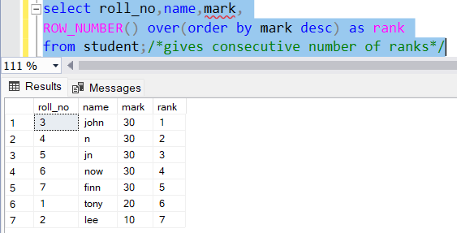

Rank:

Duplicate rank number gets jumped

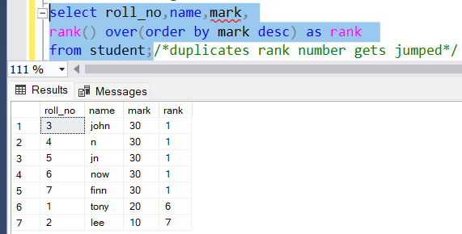

Dense_rank :duplicates have same ranks

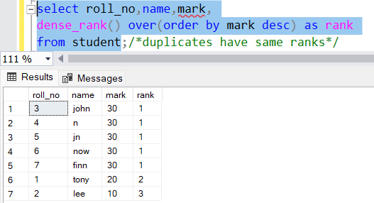

Ntile:groups the rank based on argument given

